Walk 41 Bishops Frome
Last walked in November 2016

Description. A 7 km (4.3 mile) strenuous walk. Climb a small hill, where spectacular views open up, and continue through farmland with orchards, hop fields, crops and pasture.
Start. The churchyard in Bishops Frome. Park behind the village hall close to the church. Explorer Map 202. Grid 663484.
Directions from Whitecross Roundabout (Turn milometer to zero). From Whitecross roundabout[0m]: Take the A4110 Canon Pyon (Three Elms road). After 1 mile at traffic lights TR. Continue on the A4103 towards Worcester and at 13.1 mile, (the bottom of Frome’s Hill), TL onto the B4214 signed Bishops Frome 1. At 14 miles, just passed the church on the R, TR and park in the village centre car park.

1. Bishops Frome. Out of the car park onto the main road and TL, after about 40 meters TL and walk thru the churchyard, passing to the R of the church, to go thru a kissing gate and out of the churchyard. St Mary’s church dates from the 12th century though little remains from that time – a notable fragment is the round arc of the south door. The font is Norman, and the tower is 14th century. The parish church contains a font over 700 years old and is approached thru a handsome lychgate. A memorial in the church features the carved figure of a knight in armour, sword in hand and a lion at his feet. Continue in the same direction to cross a bridge over the river Frome. Bear slightly R and cross over a large field {F1} to a kissing gate. Go thru the kissing gate, over a small footbridge and across {F2} to cross a stile onto a tarmac driveway. Cross the driveway and go over a stile ahead into {F3}. Go thru the middle of a field and thru a gateway gap, (which is just by a wooden electric pylon), into {F4}. Carry on, keeping to the tree line on your R, and at the end of the field you cross over a stile into a narrow enclosed grassy path. At the end of the path you cross another stile onto a narrow road.

2. Road. Cross the road and go over two stiles into {F4}. Keep the tree line/fence on your R as you gradually begin to climb and at the end of the field you cross a stile and continue along an enclosed path for a short distance and reach a narrow road. Cross the road, go over a stile and straight on up and enclosed track, wood is on your R and initially a fence is on your L. When you get to the end of the garden fence on your L you go into the woods on a steeper climb, following way markers to the top where there is a small wooden gate on your R, (ignore the stile straight ahead). Go thru the small wooden gate into {F5} and TR. Walk alongside the outside edge of the wood, which is on your R. Continue along the edge of the wood/field and just before reaching the bottom R hand corner of the field, (a white house can be seen directly in front of you), look for the gap in the hedge/trees on your R, (immediately past an electric wooden pylon in the hedge), and TR to go over a stile, then down a few steps onto a gravel drive where you TL and go thru a large wooden gate onto a road. TL, climbing slightly at first, follow this road for about a kilometre, passing under high voltage national grid cables, until you reach a tall radio mast on your R. TR at a bridleway sign to pass thru the small wooden gate that’s next to a large metal gate, into {F6} and walk on past the R hand side of the radio mast, staying close to the field boundary.

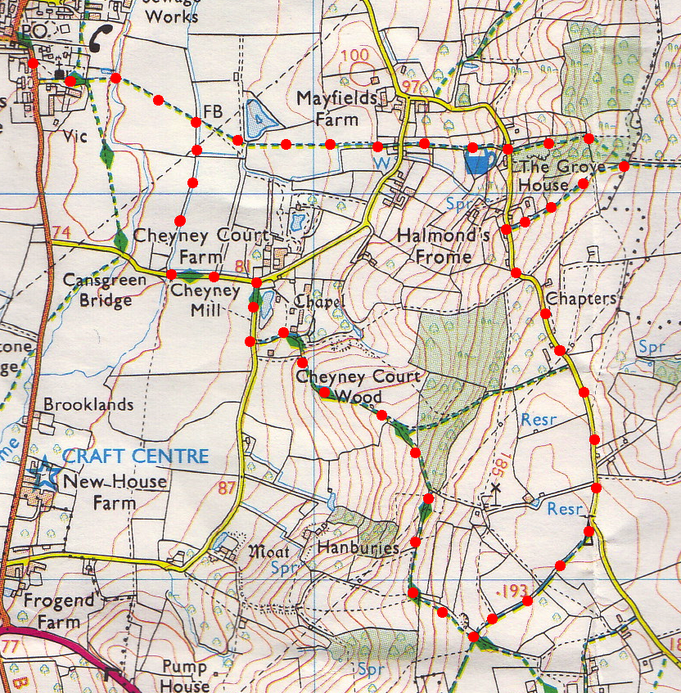
3. Three Fields. With fence/hedge on your R, proceed thru this small field and two more {F7}{F8} and then, after a short distance, go thru a small wooden gate which is on your R hand side into {F9}. Keep straight ahead but now with the hedge on your L. At the end of the field you go thru a large metal gate into {F10} and TR. Stay close to the hedge/fence on your R; descend slightly to the end of the field but don’t go thru the metal gate, cross over the stile which is in the R hand corner of the field, by the fence. A few paces further on you TR and walk along the top edge of {F11}, (the tree line/fence is on your R), to reach the R hand corner where you then cross a stile (a large stone slab is to the R). Walk along a ditch, (fence is on the L) and continue on, to walk along the edge of {F12} and reach another stile. Cross the stile, TL and descend down a track that keeps to the L hand side of the wood. At the end of the wood cross a stile into {F13} and continue on down hill, keeping to the fence on your L, until you reach Cheyney Court which isn’t seen until you are nearly on it. Bear L and cross a very trendy stile with two rungs that lift up to enable small people to cross with ease. Walk on down the drive passing to the L of the recently modernised Cheyney Court and at the road (sign to Cheyney Park and Chapel) TR. Reach a T-junction and TL, walk down the road. Near the bottom you pass a house on your R that was an old mill, also recently modernised. 50m further on you cross over a river bridge (river Frome), and TR at the way marker post to go thru a gap in the hedge into {14}. Follow the R field edge, keeping close to the river. At the end of this large field, over on the L side, is the old Vicarage. TL to walk thru the kissing gate, thru the churchyard and out onto the road where you TR, and back to the car.
1
2
3

